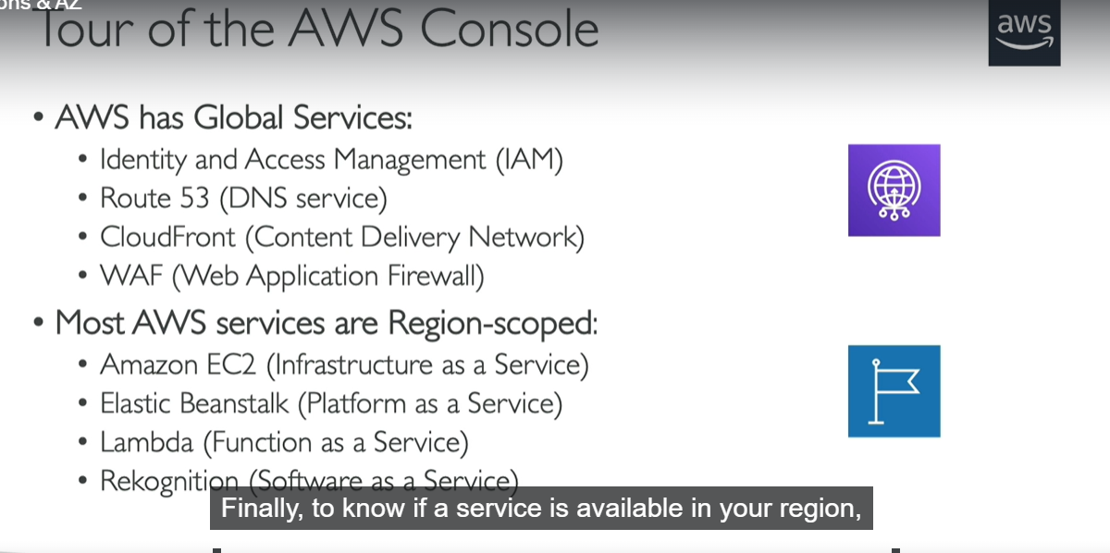

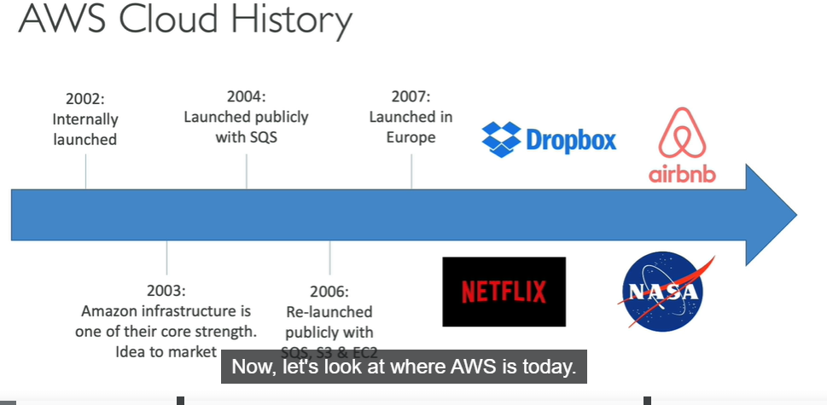

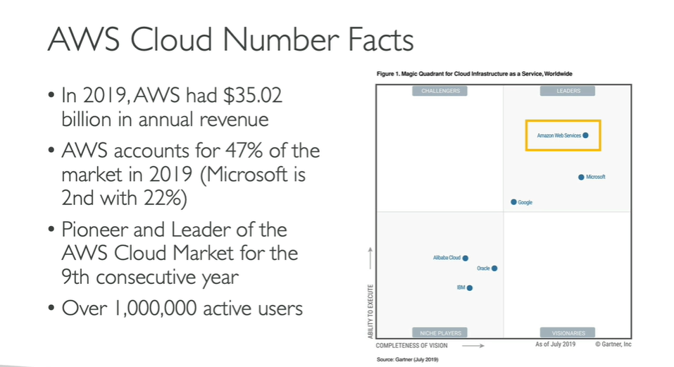

GRAVITON IS THE NEW AWS PROCESSOR WHICH IS CREATED BY AWS BUT ITS ONLY WORKS WITH LINUX



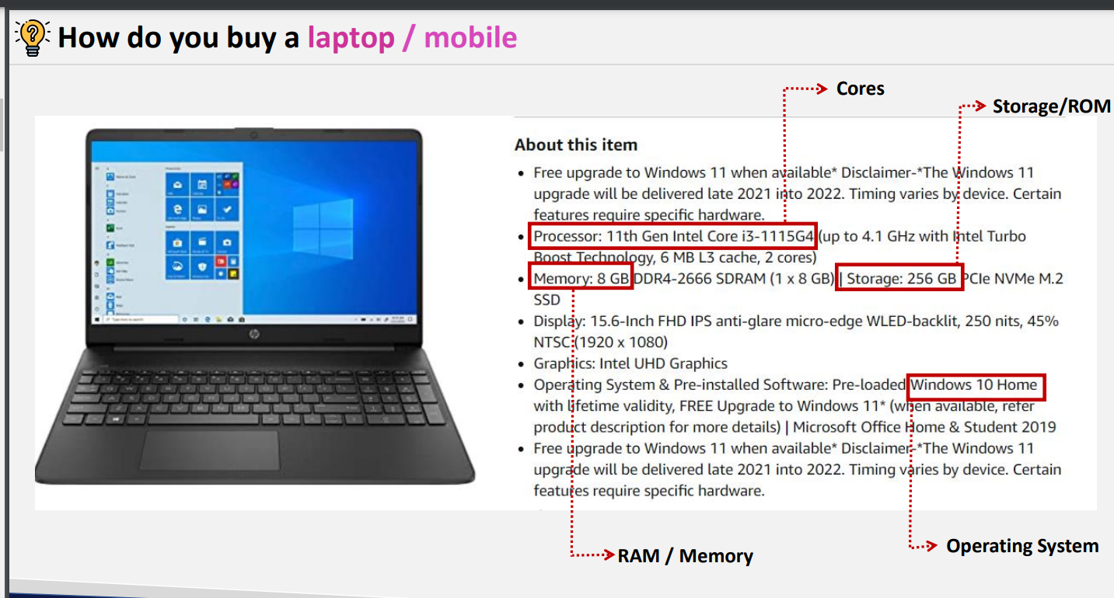

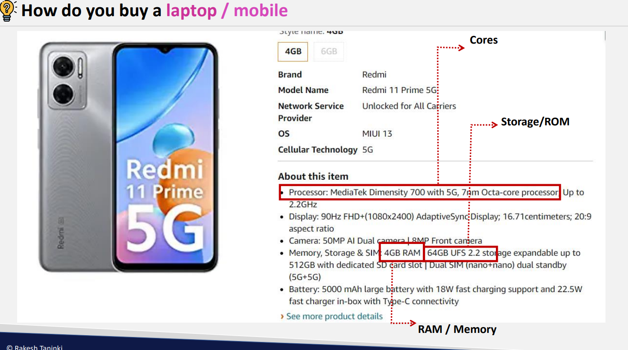

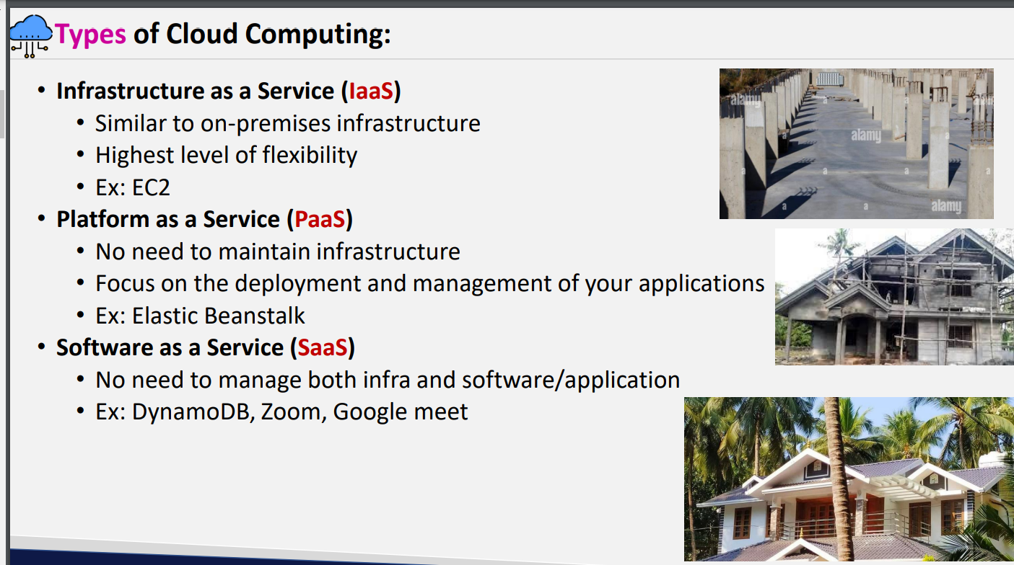

Infrastructure as a service: every thing should be managed by us starting from base

Paas: half infrastructure is built already and rest part needs to be managed by us just you need give application code and data

Saas: Everything is managed by cloud ……just we need use it .

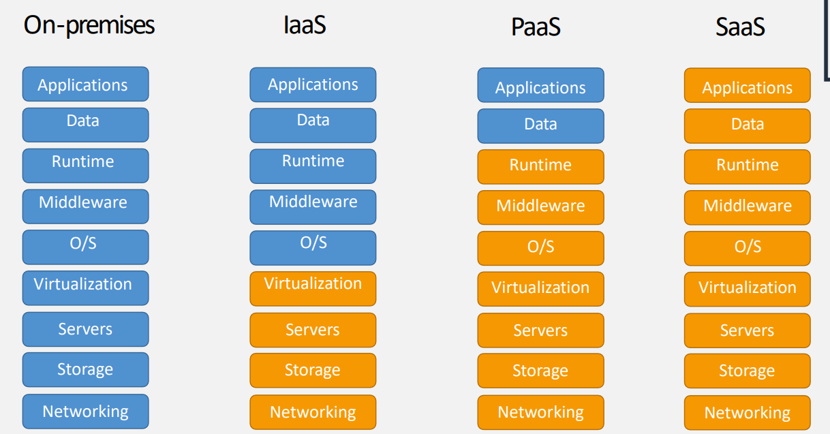

Pricing model:

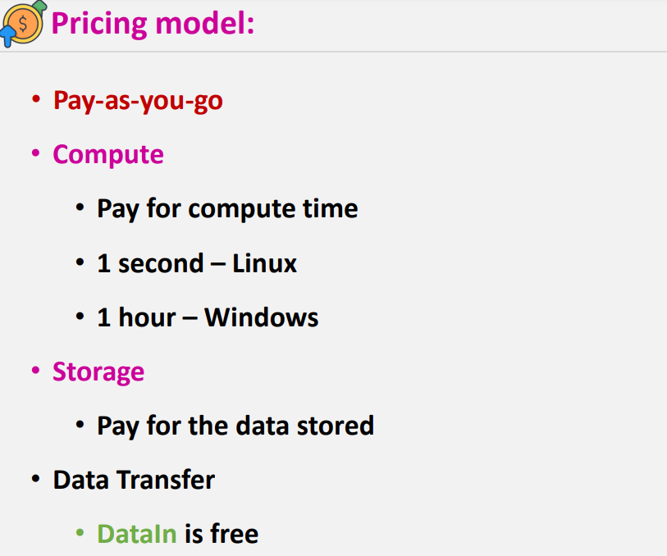

* Linux pricing is bit less when compare to windows bcz as windows is licenced & it needs to pay some amount to Microsoft for windows
* **Storage :** storage will be for some services it will be like disk cost for ex: if you are taking 10gb hard disk and if you are utilizing only 5 gb you need to pay for entire 10gb like “**EBS”,”FSX” etc**

**Ex2**: for some services it will be like pay as you go model like **S3 its scable**

Data in into the AWS is free and data out from AWS will be charged

* Example if you are uploading 1 GB of data in to the AWS it will be free and if you are downloading 1Gb of data from AWS it will be charged

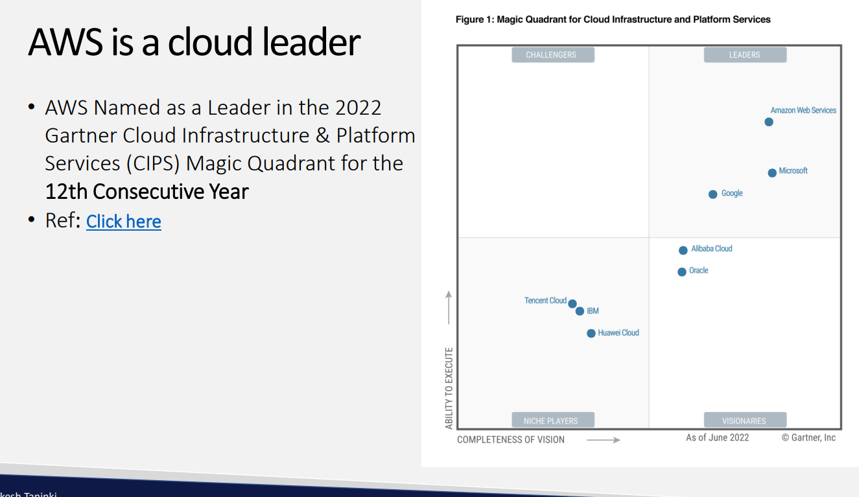

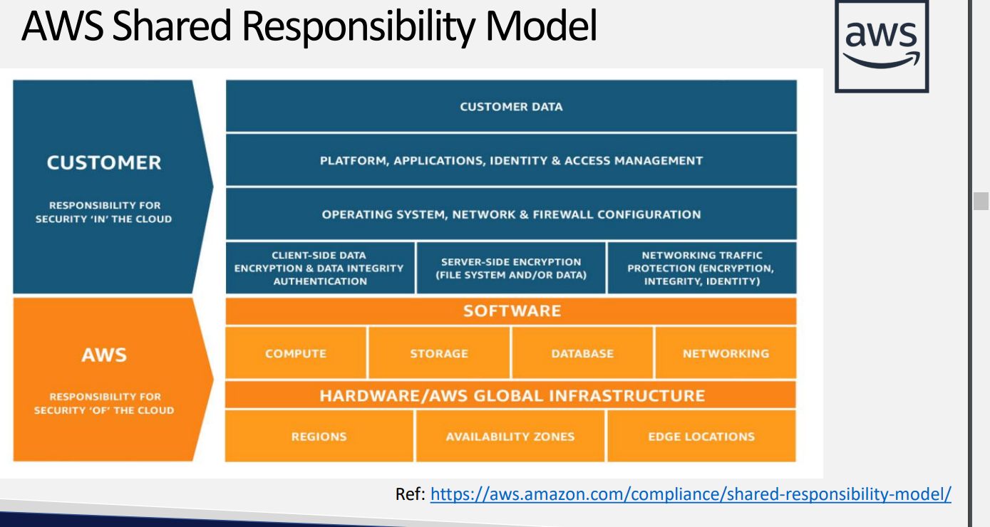

https://aws.amazon.com/compliance/shared-responsibility-model/

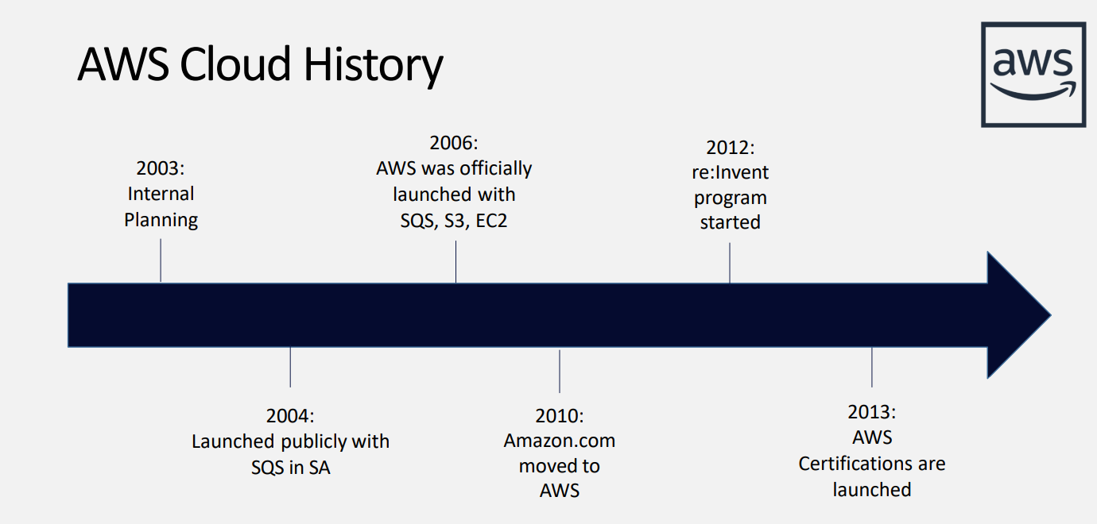

From 2012 on wards aws is launching reinvent program they will update the services and the features over this reinvent program

Every year they will update some features

For pricing click on pricing

* For resources docs click on resources
* For user guides **ex aws s3 user guide**
* Services cost differ from region to region
* **FREE TIER LIMITS : https://aws.amazon.com/free/?all-free-tier.sort-by=item.additionalFields.SortRank&all-free-tier.sort-order=asc&awsf.Free%20Tier%20Types=*all&awsf.Free%20Tier%20Categories=*all&all-free-tier.q=key&all-free-tier.q_operator=AND**

Best practices for root account

1. Setup MFA – hands on

2. Never share your root account password or access keys bcz if you share it your data which is created in your act might be mislead as root act have every access

3. Use strong password policy

4. Create users to perform tasks

5. Don't create access keys for the root (Only for certain tasks root account will have access keys its for billing purpose , organization services and for joining 3, 4 aws account etc etc as root account has unlimited access.

Budget plan : you can set budget plans so that aws sends you a notification trigger if you exceed that budget

* Youcan set budgets even for services separately
* You can add thresholds for sending alarms after exceeding %
* In bills section you can get the details for which service you got charged
* Invoice will be account wise

Regions and availability zones

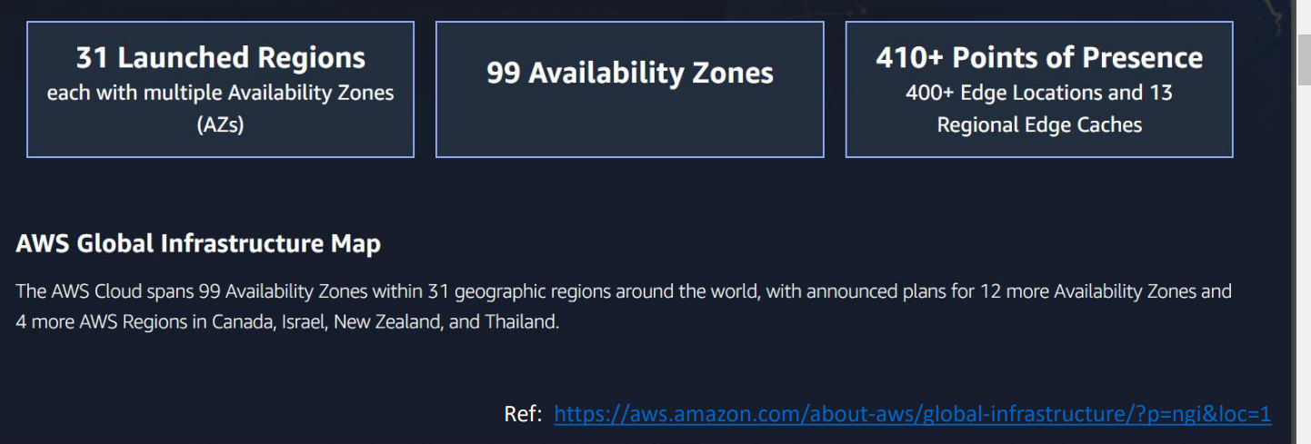

Ref : <https://aws.amazon.com/about-aws/global-infrastructure/?p=ngi&loc=1>

* Coming soon regioions

Regions

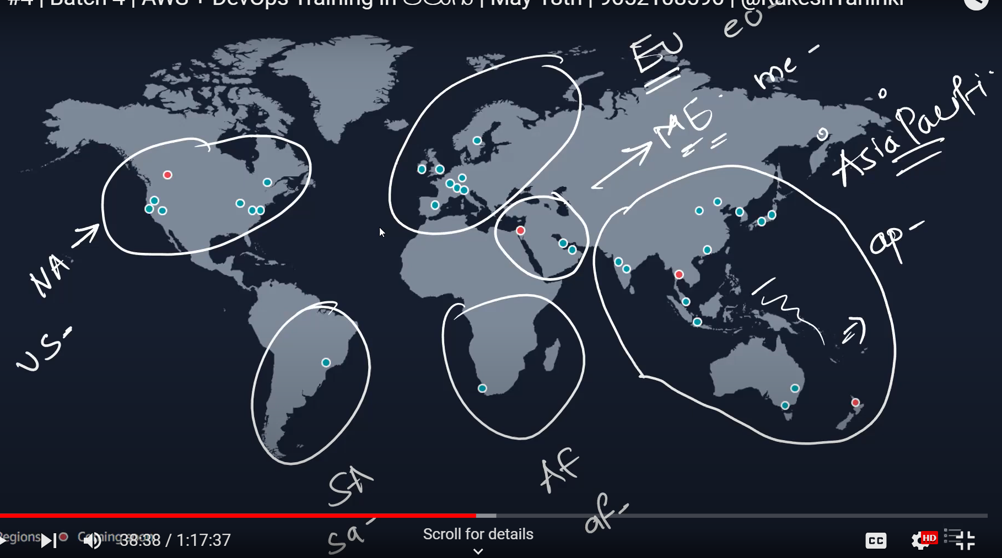

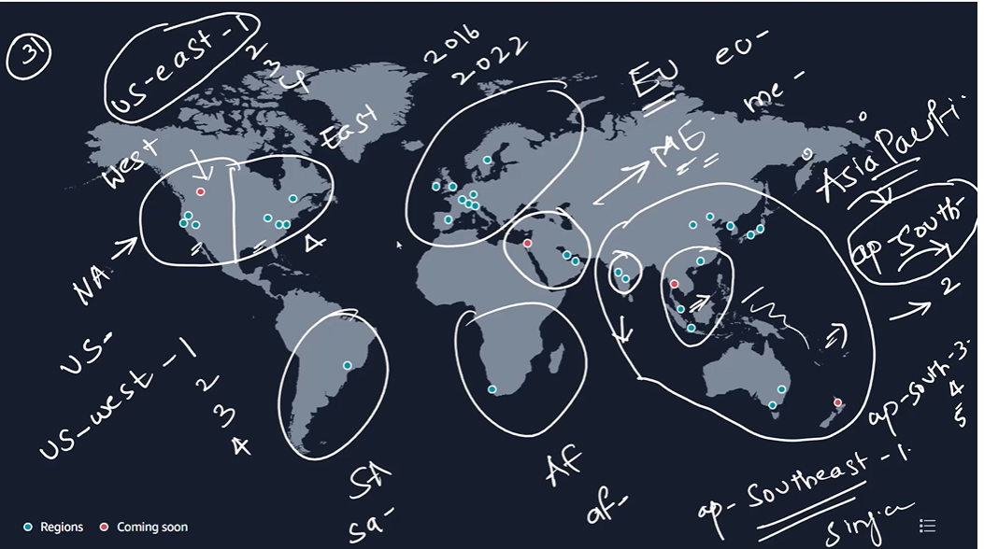

Based on region age new services which will release in event every year it will be launched in old regions not in every region for testing purpose

With in six months those services will be available in other regions too

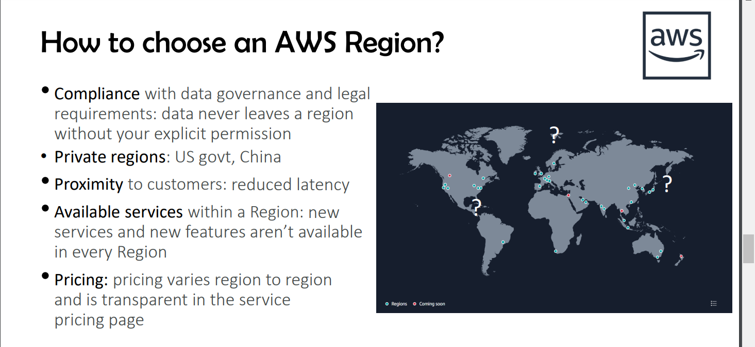

Compliance : example for every country there will be sensitive data so they don’t want to expose outside from there country

Private regions: it wont be accessible publicly as they want private access for there environment

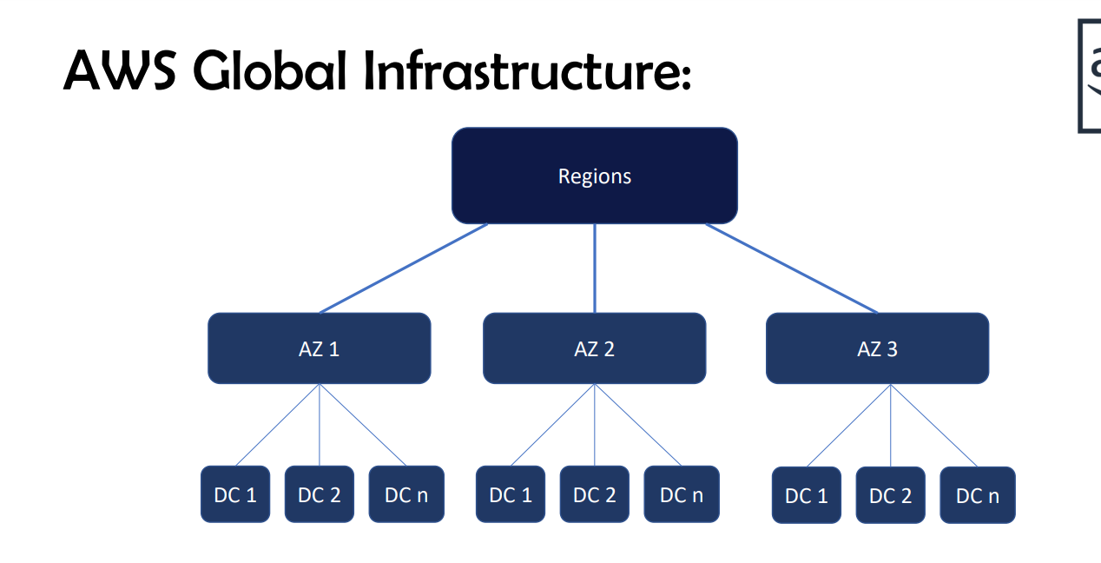

Regions : group of AZ

Az’s: group of data centers

AWS maintaions minimum 100 KMS Distance between 1 AZ to another AZ as they should not affect grouply by natural calamities

So that we can get back up from another AZ

Cooling system will be there to cool data centers so that they cant balst bcz of high heat

* Every region has MINIMUM three AZ’S
* 1AZ is effected means all the DC’S gets effected as its main hub
* If you want to store your in data in multiple AZ’s you will be charginging accordingly
* Between the dc’s there is wired connection
* There is region HA where you can pay for it to store multiple az’s and also you have High AZ availability where you can store in multiple dc’s

